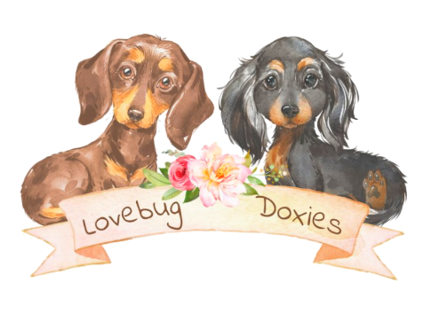
-- Puppy Purchase Contract --

____________________________________________________ (Hereinafter referred to as "SELLER")
_____________________________________________________ (Hereinafter referred to as "BUYER")

Buyer's address:__________________________________________________________________
Buyer's phone number:_____________________________________________________________
Buyer's Email address:_____________________________________________________________
{Seller fills in puppy info}

Puppy’s Birth Name:_______________________________________________________________
Puppy's Color:__________________________________Coat Type:________________________
Puppy's Sex:_________________________Whelping Date:_______________________________
Sire's Name:____________________________Dam's Name:______________________________
The following payments are NON-REFUNDABLE. Should a family emergency or change in circumstance arise prior to said puppy reaching 8 weeks of age your reservation fee may be transferable to a future litter. Transfers will be at the Seller's discretion and will only be valid for one year from the date they were received. Reservations may be paid electronically or via money order. Balance due upon pick up is strictly CASH only.

Reservation Fee: $ ________________________ Date Received: __________________________
Total Adoption Fee: $ _______________________ Date Received: _________________________
This puppy is ready for pick up on the following dates:____________________________________

If you encounter an emergency and cannot keep your pick up appointment please contact me right away so we can reschedule promptly. Failure to pick up your puppy in a timely manner will result in forfeit of any payments received and the puppy will be placed for adoption again.

Buyer's Initials: ___________________

Health Certification:
The Buyer has 48 hours from the date of sale to have the puppy examined by a veterinarian of their own choice, at their own expense. If the vet exam reveals that the puppy has a life-threatening genetic defect, the Buyer must contact the Seller on the day of the office visit. Buyer will then have the option of returning said puppy within 5 days along with a written diagnosis from the attending vet in exchange for a replacement puppy of equal value as soon as one becomes available. Returning the puppy will be at the Buyer's expense and must be conducted within 5 days for the Buyer to be entitled to a replacement puppy. Replacement is the only option. No refunds will be made. No veterinary bills will be paid by the Seller. Genetic defects that are NOT life-threatening (such as a kinked tail) are NOT covered by this warranty.

Said puppy has been treated for common parasites and has received their first combo vaccine by following an age and breed appropriate protocol. It is important to follow up with further booster shots and parasite treatments according to veterinarian recommendations. Starting a monthly flea/heartworm treatment at your first appointment is wise as 8 weeks of age is the soonest those treatments become a viable option. Dachshunds tend to be sensitive to certain vaccines and may develop an allergic reaction. Please keep this in mind and monitor carefully after each booster. We do not recommend the use of the Leptospirosis vaccine at all.

Buyer's Initials: ___________________

Typical Adjustment Period:

For puppies going to a new home, meeting new people and pets, and sleeping alone for the first time is a scary experience.

Mild distress including crying and barking, mostly at bedtime, is to be expected during the first few days away from their mother and littermates. Slight tummy upset can occur during these times of stress. Shivering is also a common sign of stress. Every puppy will react differently.

All of these behaviors and symptoms are temporary and resolve themselves typically within just a few days to a week with consistent training, reassurance, and care during the adjustment period.

Please do not adopt a puppy if you cannot cope with some night time crying, or if your living arrangements (ex: apartments) will not tolerate such behaviors.

Buyer's Initials: ___________________

Spay/Neuter agreement:
Said puppy is being sold as a companion with no AKC registration. Spay/neuter is required by the age of 9 months. Proof of procedure must be provided to the Seller within one month.

If Buyer fails to provide the Seller with proof of a companion puppy’s spay/neuter procedure by the deadline there will be a fine in the amount of $500.00 as a penalty for contract violation.

Ovary sparing spay or Vasectomy are recommended if your veterinarian offers those hormones preserving options. Hormones assist with proper growth and development, lessening the risk of IVDD, weigh gain, and coat changes in Dachshunds. Removing the ability to reproduce while preserving the hormones is the most ideal scenario.

Buyer's Initials: ___________________

Restrictions:
Buyer agrees said puppy will be solely owned and housed by the Buyer for the duration of the Dachshund's life.
If said puppy ever needs rehomed for any reason it is agreed that he/she will be returned to the Seller so that an appropriate home can be found, and Seller can keep track of the whereabouts of said pup. No refund will be made for returning this puppy to be rehomed by the Seller.

In the event this puppy is sold, given away, or taken to the pound/shelter by the Buyer there will be a fine in the amount of $500.00 as a penalty for contract violation. If the puppy/dog is still legally obtainable by the Buyer, they agree to retrieve it and return it to the Seller.

Buyer's Initials: ___________________
Seller reserves the right to cancel this transaction prior to pick up, for any reason, with a full refund, should they deem this placement no longer suitable.
It is agreed that the place of venue for any legal dispute between the Buyer and Seller will be Kent County Michigan. This contract represents the entire agreement between the parties. No other agreements or promises, verbal or implied, are included unless specifically stated herein. When Seller and Buyer execute this contract, it will be binding upon both parties, subject and pursuant to the terms and conditions herein.
Having read the above, and with full understanding of the contents herein, I willingly enter into this agreement.
Buyer________________________________________________ Date: _______________________
Seller_______________________________________________ Date: ________________________

